Nama: Geraldine Raphael Sidauruk

Nim: 535240128

No 1

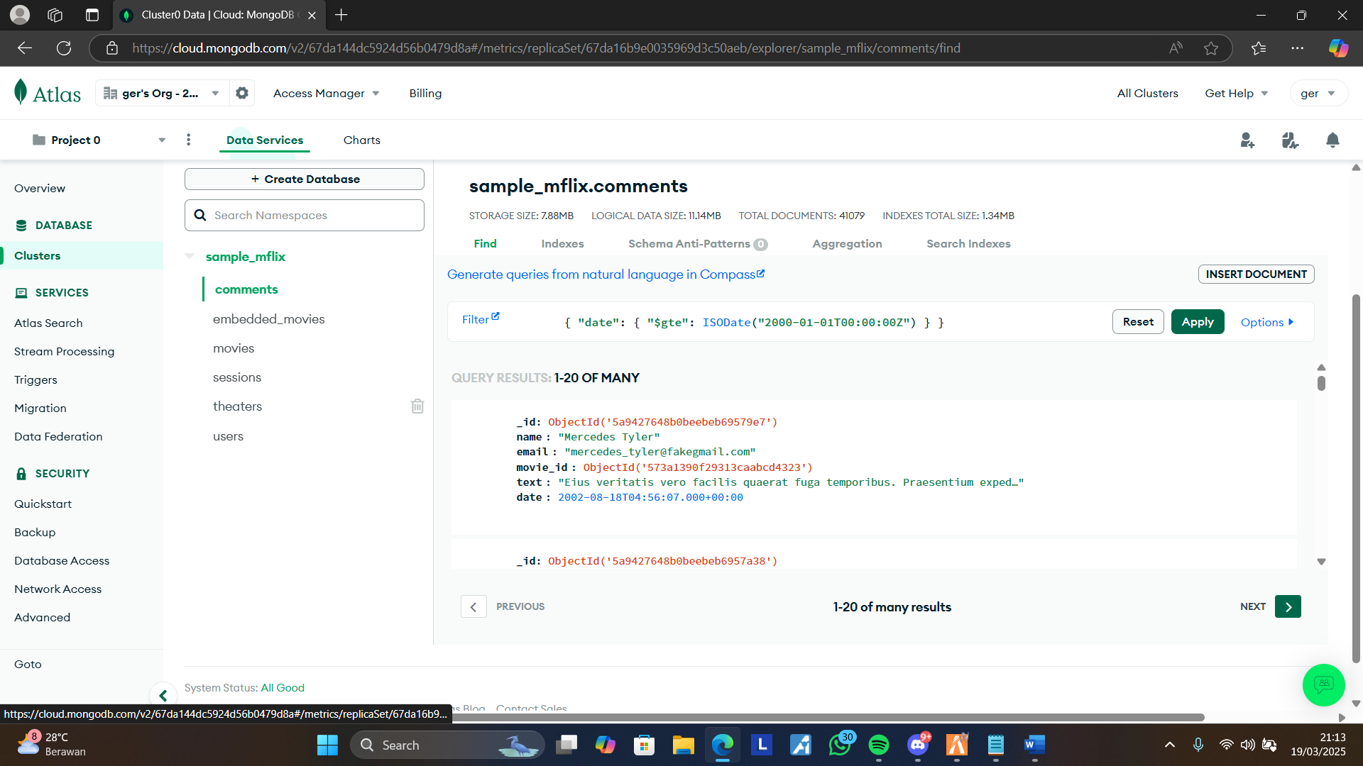

Filter: { "date": { "$gte": ISODate("2000-01-01T00:00:00Z") } }

No 2

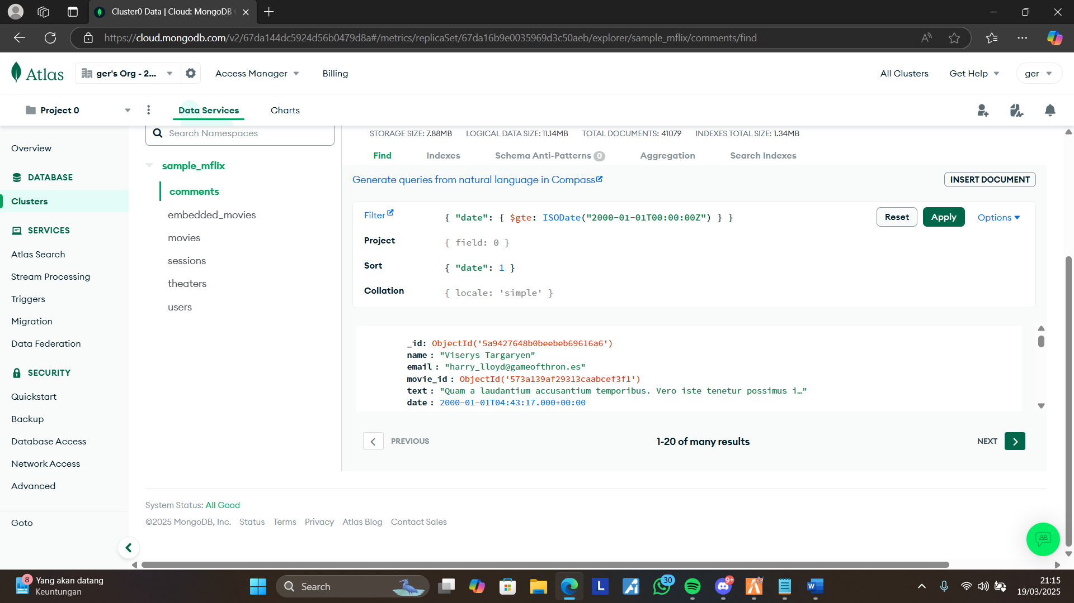

Filter : { "date": { $gte: ISODate("2000-01-01T00:00:00Z") } }

Sort : { "date": 1 }

No 3

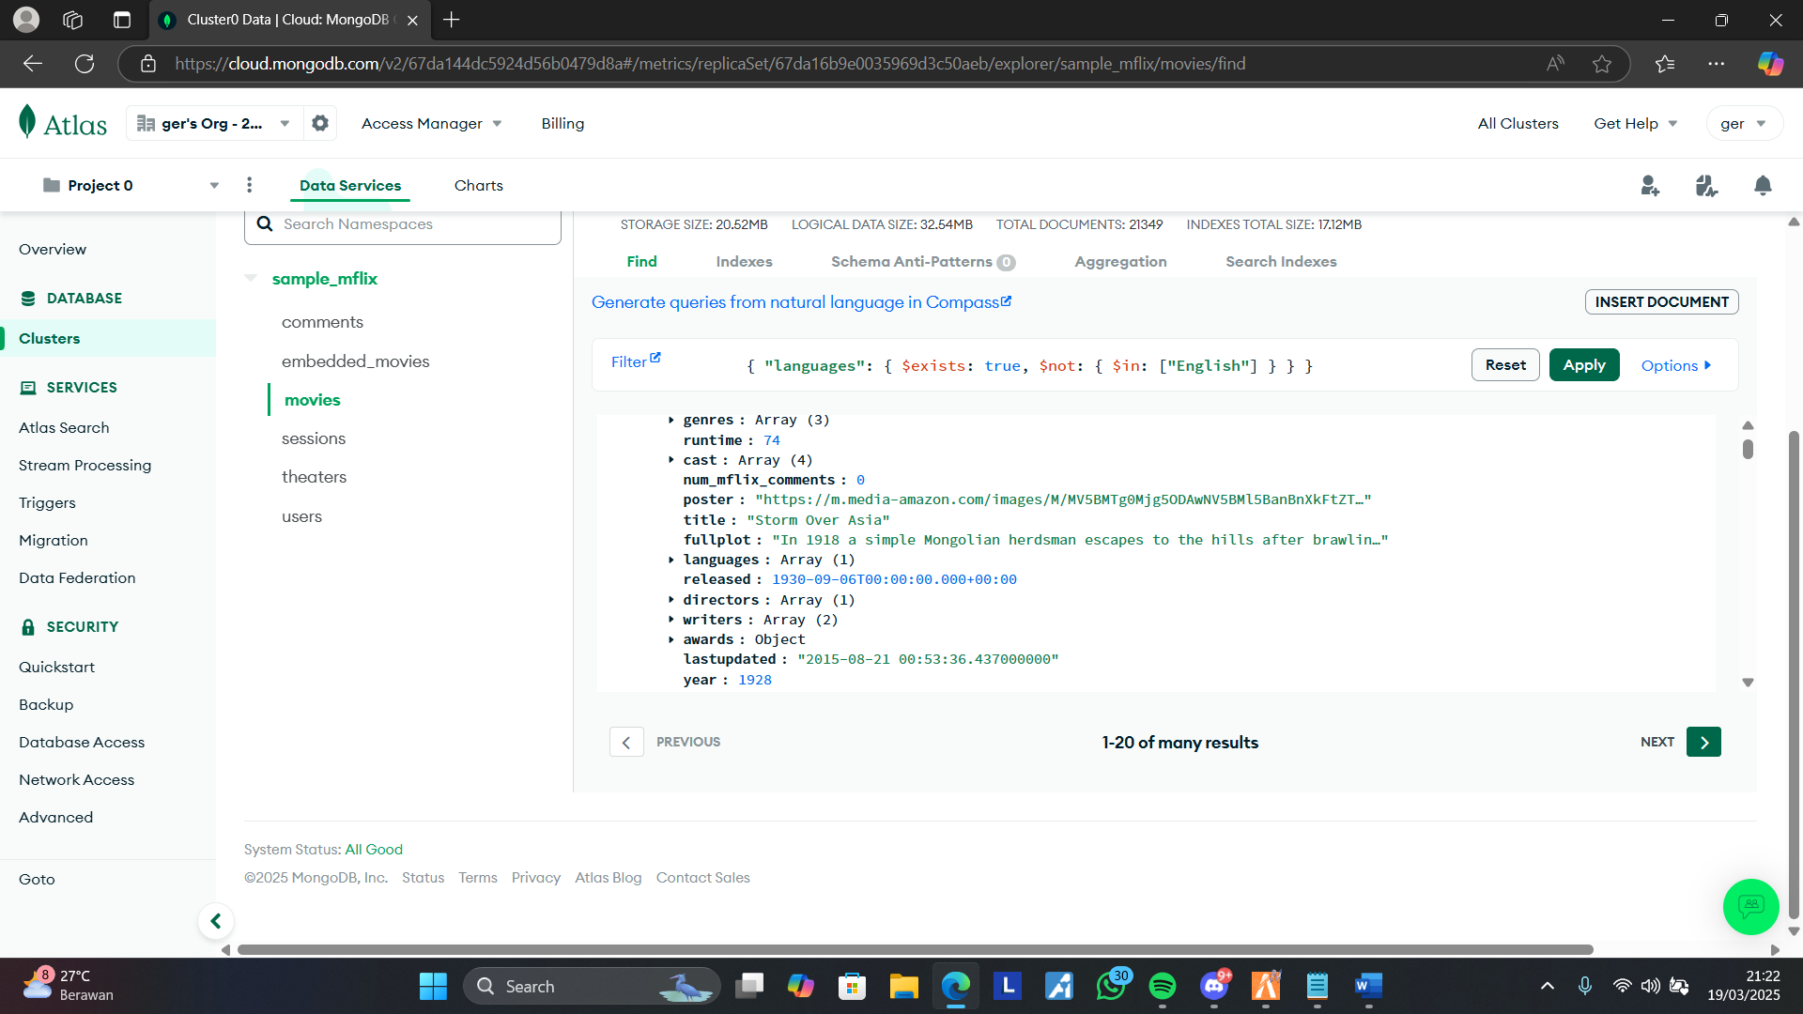

Filter : { "languages": { $exists: true, $not: { $in: ["English"] } } }

No 4

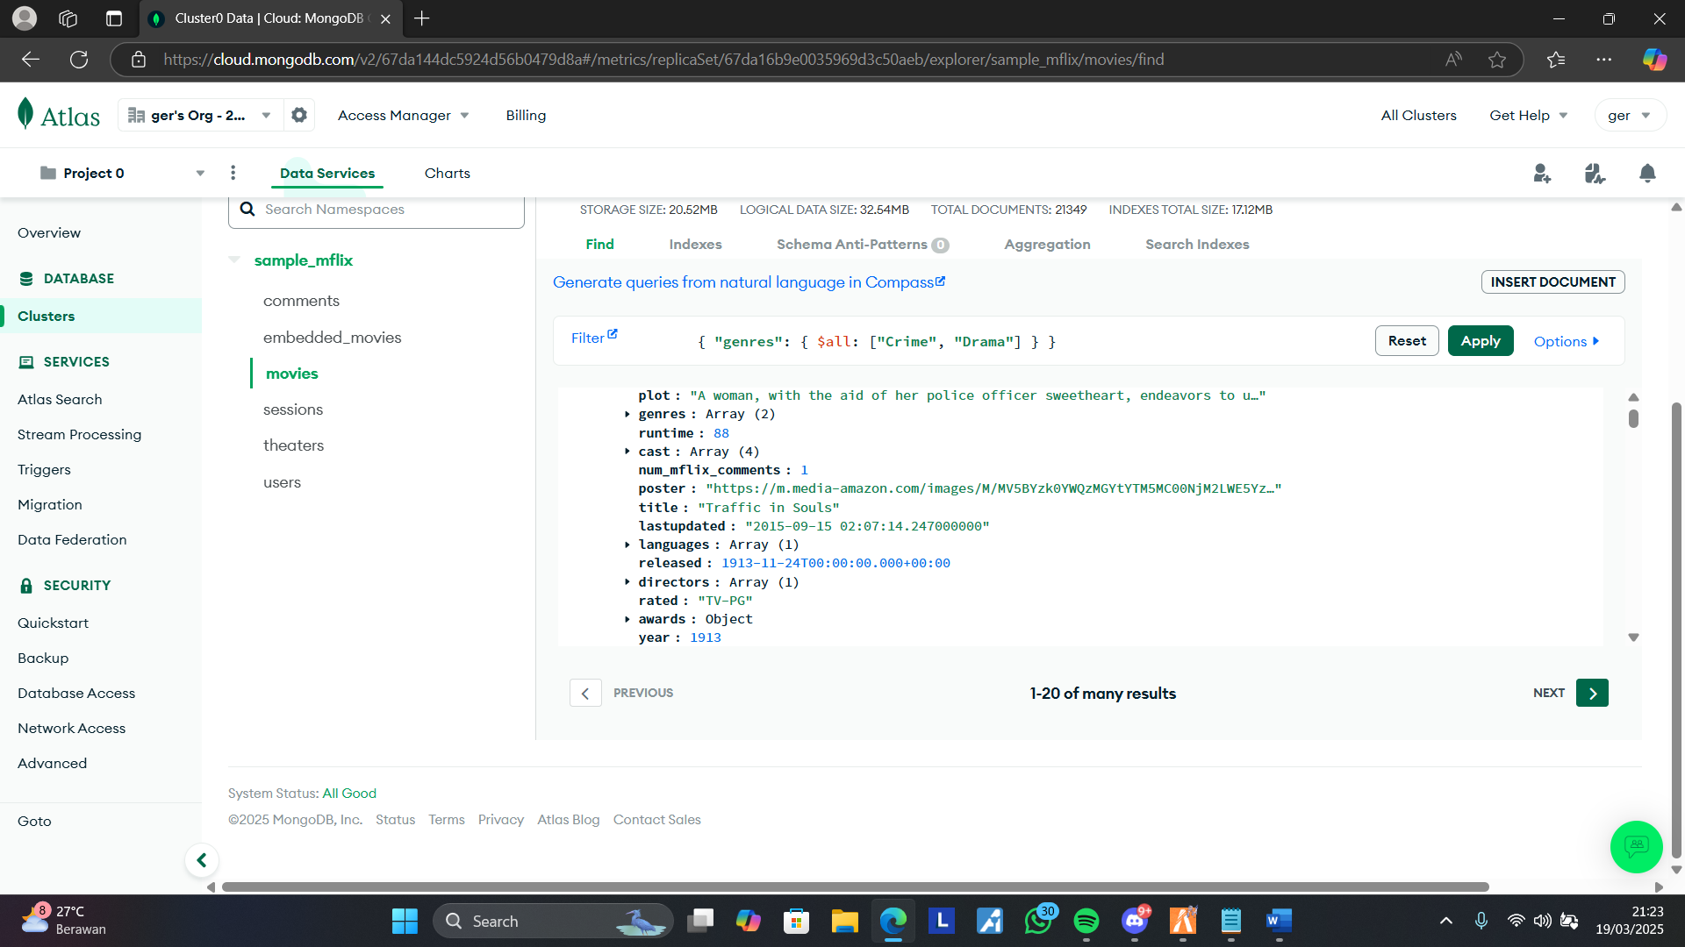

Filter : { "genres": { $all: ["Crime", "Drama"] } }

No 5

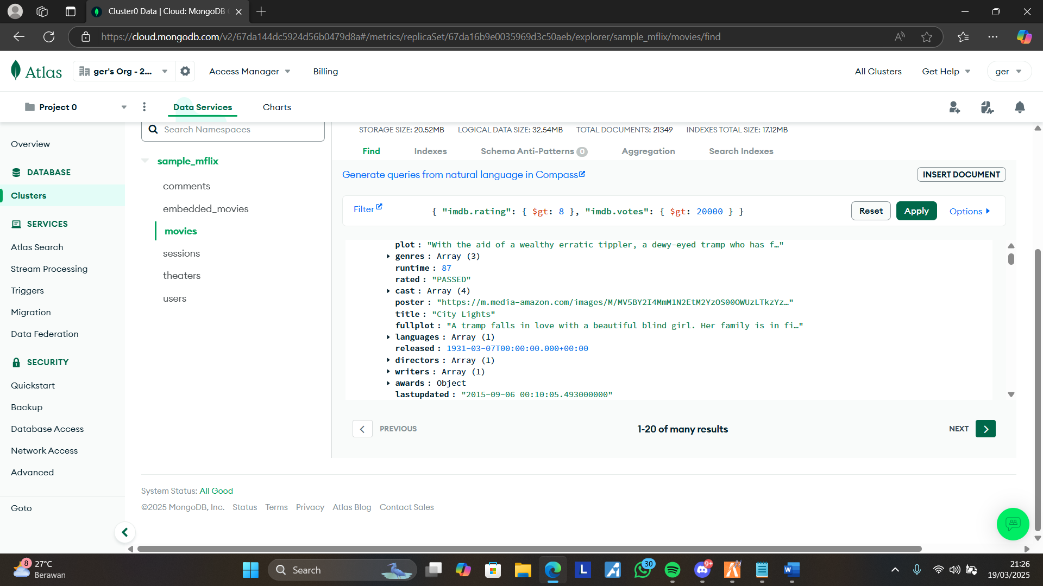

Filter: { "imdb.rating": { $gt: 8 }, "imdb.votes": { $gt: 20000 } }